BT5151 Group Project Pipeline:
preprocess_data → train_models → evaluate_models → select_model → persist_artifacts
preprocess_data → organisational
train_models → organisational
evaluate_models → llm_driven
select_model → organisational
persist_artifacts → organizational

Updated pipeline:

SKILL.md files - Training Pipeline
File
preprocess_data.md
train_models.md
evaluate_models.md
select_model.md
persist_artifacts.md

SKILL.md files - Serving Pipeline
File
detect_language.md
translate_to_english.md
run_inference.md
confidence_router.md
draft_response.md
apply_feedback.md
log_interaction.md

TRAINING PIPELINE (runs once)
──────────────────────────────────────────────────────
preprocess_data_node
│ reads: raw_data_path
│ writes: train_texts, val_texts, test_texts,
│ y_train, y_val, y_test,
│ tfidf_vectorizer, label_encoder
▼
train_models_node
│ reads: train_texts, y_train, val_texts, y_val
│ writes: trained_models (LR + SVM + NB, all calibrated)
▼
evaluate_models_node
│ reads: trained_models, val_texts, y_val, label_encoder
│ writes: evaluation_results, evaluation_narrative
│ LLM: GPT-4o-mini interprets metrics in business language
▼
select_model_node
│ reads: evaluation_results, trained_models, val_texts, y_val
│ writes: selected_model, selected_model_name, tau_high, tau_low
▼
persist_artifacts_node
│ reads: selected_model, tfidf_vectorizer, label_encoder, tau_high, tau_low, selected_model_name
│ writes: artifacts_saved = True
│ saves to disk: model.pkl, tfidf_vectorizer.pkl, label_encoder.pkl, thresholds.json, model_info.json
▼
END

SERVING PIPELINE (runs once per customer message)
──────────────────────────────────────────────────────
[Customer submits message via Gradio UI]
│
▼
detect_language_node
│ reads: raw_message
│ writes: detected_language
▼
translate_to_english_node
│ reads: raw_message, detected_language
│ writes: translated_message
│ LLM: GPT-4o-mini translates if not English
│ skip: if detected_language == English, translated_message = raw_message
▼
run_inference_node
│ reads: translated_message
│ loads from disk: model.pkl, tfidf_vectorizer.pkl, label_encoder.pkl, thresholds.json
│ writes: predicted_label, confidence_score, class_probabilities, trace_logs entry
▼
confidence_router_node
│ reads: confidence_score, tau_high, tau_low
│ writes: route_decision
│ AUTO_REPLY if confidence >= tau_high
│ CLARIFY if tau_low <= confidence < tau_high
│ ESCALATE if confidence < tau_low
▼
draft_response_node
│ reads: predicted_label, route_decision, translated_message
│ writes: response_final
│ LLM: GPT-4o-mini polishes template response
▼
log_interaction_node
│ reads: full state
│ writes: to SQLite database
│ tables: interactions, trace_logs
▼
[Response shown in Gradio Customer UI]

ADMIN ACTIONS (triggered by Admin UI buttons)
──────────────────────────────────────────────────────
[Admin flags a response]
│
▼
apply_feedback_node
│ reads: flagged interaction, corrected label, corrected response
│ writes: to SQLite feedback table
│ immediate: adds to approved response memory
▼
retrain_from_feedback_node ← triggered by "Retrain" button
│ reads: feedback table from SQLite
│ writes: new model version
│ runs: full training pipeline with feedback data appended
▼
[Updated model deployed, model_version bumped]

State Fields Summary
SupportAgentState
├── Pipeline control
│ ├── messages: list[str]
│ ├── active_skill: str
│ └── mode: str ("train" or "serve")
│
├── Training path
│ ├── raw_data_path: str
│ ├── raw_df: DataFrame
│ ├── train_texts, val_texts, test_texts: sparse matrix
│ ├── y_train, y_val, y_test: numpy array
│ ├── tfidf_vectorizer: fitted TfidfVectorizer
│ ├── label_encoder: fitted LabelEncoder
│ ├── trained_models: dict (3 models)
│ ├── evaluation_results: dict
│ ├── evaluation_narrative: str
│ ├── selected_model: sklearn model
│ ├── selected_model_name: str
│ ├── tau_high: float
│ ├── tau_low: float
│ └── artifacts_saved: bool
│
├── Serving path
│ ├── conversation_id: str
│ ├── raw_message: str
│ ├── detected_language: str
│ ├── translated_message: str
│ ├── predicted_label: str
│ ├── confidence_score: float
│ ├── class_probabilities: dict
│ ├── route_decision: str
│ └── response_final: str
│
└── Audit
└── trace_logs: list[dict]
Comparing 3 Models
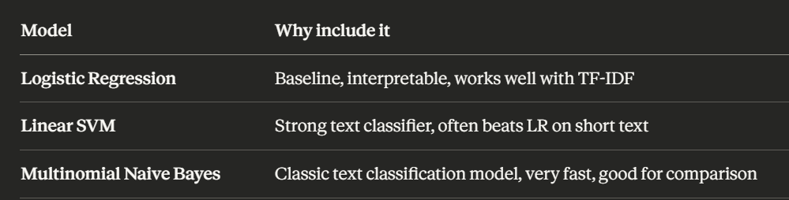
Why Naive Bayes instead of Gradient Boosting or Random Forest? Because TF-IDF matrix has 169 features from very short text. Tree-based models struggle with sparse high-dimensional text features. Naive Bayes is specifically designed for text and gives you a meaningfully different comparison story to tell.
Every SKILL.md must include:
- name
- description
- When to use
- How to execute
- Inputs from agent state
- Outputs to agent state
- Output format
- Notes

SKILLS.md
preprocess_data.md → organisational
train_models.md → organisational
evaluate_models.md → llm_driven
select_model.md → organisational
persist_artifacts.md → organizational

select_model.md → organisational

Personal Notes:
- tau_high and tau_low are derived empirically from the validation set using a precision-confidence curve, not hardcoded. tau_high is set at the lowest confidence threshold where precision >= 0.90. tau_low is set where precision on low-confidence samples drops below 0.70. This ensures routing decisions are data-justified.

Three End-to-End Test Cases
Required by rubric - you run these after full pipeline works:
Test Case | Input | Expected Output
Case 1 | Clear English message | High confidence → AUTO_REPLY
Case 2 | Non-English message (Chinese/French/Japanese) | Translated → classified → reply
Case 3 | Ambiguous short message | Low confidence → CLARIFY or ESCALATE

